**Research Proposal for Bachelor Thesis**

**Effects of different 3D Printer Nozzles Material on 3D printing Polylactic Acid (PLA) and it’s Abrasive derivatives**

**Andika Bramantio Wicaksono (11201902005)**

**Introduction**

3D Printing is a process of creating a 3D model or object into reality, it was first developed in the 1981 by a Japanese Researcher Hideo Kodama with a layer-by-layer technique. In which later most popularly known as a Fused Deposited Modeling (FDM). It is a part of a wider technique known as the Additive Manufacturing Method because it involves of adding/fusing a material to create the product.

Nowadays, many and many more 3D printers has entered the market and the price of 3D printer has becoming more affordable to purchase even for home consumer grade. Which also came along with the fact of more and more material being developed to meet the requirement of 3D printing by many types of the customers.

The material used for 3D printing by Fused Deposition Modeling is called a Filament. A filament is a thermoplastic that must follow a Heating, Extruding, and Cooling Process during a printing cycle. The process began with the Filament being Heated to just slightly above its glass transition temperature inside a chamber that is more known as a Hotend. Then it is extruded by the Hotend to a flat surface where it will be cooled down. The process is continuing layer by layer to make a finished model.

There are several types of Filaments that available in the market. The most used for 3D printing are Polylactic Acid (PLA), Acrylonitrile Butadiene Styrene (ABS), Polyethylene Terephthalate Glycol (PETG). There are also some Unique and Exotic types of filaments that is available for 3D printing, although they might require some special modification to the machines or the printing environment to get the most optimized results out from them.

One of the types of Exotic/Unique Material is Abrasive type of filaments. These kinds of Filaments can cause accelerated wear damages for the stock brass-made nozzle for 3D printer. To print them effectively without making much damage to the printer itself, some modifications are required to effectively use the abrasive type of filaments. For example, Wood Filaments which is a blend of basic PLA and some wood fibre to make it’s unique Wood-like feel.

Some Popular Nozzle Material to use for 3D printing:

* Brass Nozzle
* Stainless Steel Nozzle
* Hardened Steel Nozzle
* Copper Plated Nozzle
* Ruby Tipped Nozzle

**Literature Review**

The 3D printing process or more known as Additive Manufacturing is a process which adding a melted plastic called filament layer-by-layer in order to create a pre-defined 3D model and sent into a software that will be “slicing” the model into layer-by-layer and made a series of command that any additive manufacturing machines could understand which is the Gcode. Some of the most common software are Ultimaker Cura, Prusa Slicer, SuperSlicer, and many more software in order to achieve a better quality of the results.

The Additive Manufacturing process offers an efficient technique of creating a model part at the lowest cost possible and required no further post processing/tooling/manufacturing required. And also has been proven to be able to create a complex geometrical parts safely and it’s safe to use at home and office environments.

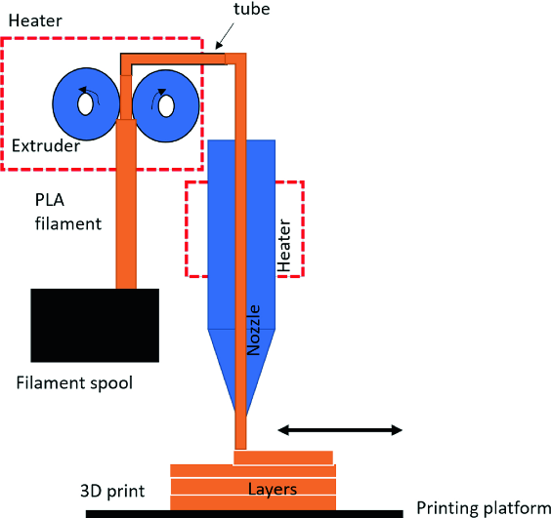

**Fig 1. The Principle of Fused Deposition Modelling**

Although all the Process of the Additive Manufacturing can be pretty interesting to be study and used for daily purposes, it also comes with its own disadvantages such as limited working space, a lower resolution when it comes to printing a smaller details, and sometimes could be prone into breaking when there is a force applied parallel to their layers.

And there is some specific times when it comes to do really need have to change the standard brass nozzles which is commonly found on the most 3D printer nowadays. Usually in order to printing an exotic printing material that could potentially damaging the standard brass nozzle. They’re called the abrasives material.

Abrasive Material can come in many ranges of quality, purposes, and most importantly price ranges. However, the most common that can be found in the market are usually are the derivatives of Polylactic Acid (PLA) that has been through addition of extra additives to make their unique properties and the look after the whole process of additive manufacturing. Sometimes the added additives that making a change in 3D printing nozzles to maintain the quality, accuracy, and longer nozzle usage life.

**Objective of The Thesis**

* Evaluating and choosing the best out of all option in the market regarding of which types of 3D printer Nozzles for daily and specific purposes

**Empirical Method and Structure of the Thesis**

The first part of the Thesis should have introduced to the reader the existing 3D printing technology especially the FDM method. The Particular interest of this part would be the background of FDM 3D Printing as well as with regard to the personal experience using a 3D printer for a while.

The Main part of the thesis should have cover how different type of 3D Printing Nozzle Material could have affects the whole process of 3D printing of Polylactic Acid (PLA) and its derivative. One of the reasons of people wanting to use a different type of nozzle for their 3D prints rather than a standard brass nozzle offered by the manufacturer. Some nozzles were made with different material with their own purpose. There should be a difference in terms of print settings and temperature because since different nozzle material have different heat transfer coefficient and thermal conductivity.

The final part of the Thesis should be covering integrating this thesis into more commonly known research regarding the nozzle material types as well as the relevance of the findings during the Thesis. Also includes what needs to be clarified in the future research and if this research is only nature or can be applied into a real-world application.

**Research Methodology**

* Using a Thermocouple Type K to measure the actual temperature in the nozzle comparing with the temperature that the 3D Printer shows on the screen  
  (Note: Thermocouple Type K is used because it can withstand heat up to 1260°C and with an accuracy of ±0.75% or ±2.2°C and with a sensitivity around 41μV/°C)
* The object that is going to be 3D Printed is a 3D printer benchy boat. Which is a common standard benchmark for a 3D printer that can shows any error regarding the dimensional accuracy, print settings, tolerances, and deviations regarding changing the nozzle types
* Drying all the test filaments before the whole process could began to ensure the dryness during print to achieve the best optimal results

**References**

Alexandra. (2022, September 13). *When was 3D printing invented? the history of 3D printing -*. BCN3D Technologies. https://www.bcn3d.com/the-history-of-3d-printing-when-was-3d-printing-invented/

Carolo, L. (2022, September 29). *The best 3D printer nozzle types, sizes & materials*. All3DP. https://all3dp.com/2/3d-printer-nozzle-size-material-what-to-know-which-to-buy/

Mwema, F.M., Akinlabi, E.T. (2020). Basics of Fused Deposition Modelling (FDM). In: Fused Deposition Modeling. SpringerBriefs in Applied Sciences and Technology (). Springer, Cham. <https://doi.org/10.1007/978-3-030-48259-6_1>

Mohamed, O.A., Masood, S.H. & Bhowmik, J.L. Optimization of fused deposition modelling process parameters: a review of current research and future prospects. *Adv. Manuf.* **3**, 42–53 (2015). <https://doi.org/10.1007/s40436-014-0097-7>

Radius, F. (2022, August 25). *Fused deposition modelling advantages and disadvantages*. Fast Radius. https://www.fastradius.com/resources/fused-deposition-modeling-advantages-and-disadvantages/